2.2 I can organise and combine information needed for webpages including across different platforms

When organising information for my website, I saved files from various sources into a folder on my desktop. Initially I used a file on my desktop to save all of my draft content and research material. For example I created a word document with my draft text and saved this in the file. I also transferred an image I had taken on my mobile to my desktop by sending it to myself via email using the share option on my mobile phone.

When using my source code editor – Visual Studio Code I was required to create a file with all the files needed for the creation of my website in one place as below;

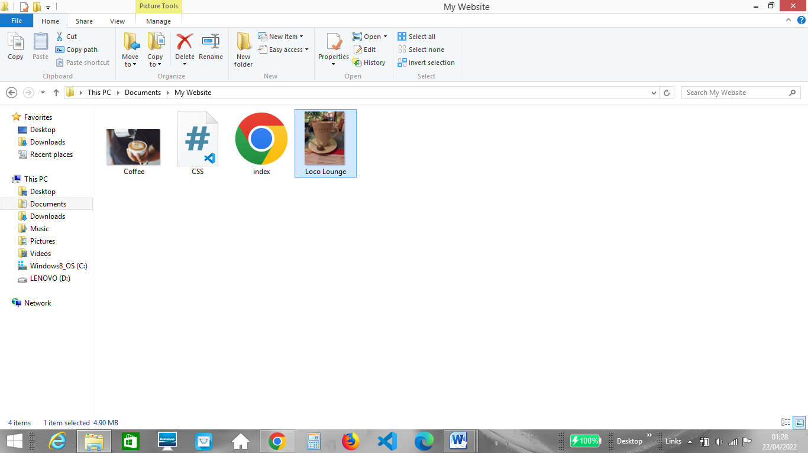

This required me to create new files including a CSS file and a html file and select files from different file locations.

When transferring the image I had taken on my mobile I sent it to myself using my email account. I copy and pasted the image into word to crop it to the size I wanted. I then right clicked on the image, selected save as picture and saved it as a jpeg file.